Design Principles - Composition over Inheritance
# Source: AI Source: Provided by: [Data Path: Persons Table -> ID Column: 1, Name_En Column: Motasem Essam] -> From: [ChatGPT] on [1/23/2026]
Composition over Inheritance is the principle of building classes by combining smaller, reusable components rather than relying heavily on class hierarchies.
👉 Think of it like building with Lego blocks: you assemble pieces to create new functionality instead of inheriting from a massive structure.

🔑 Key Points
# Source: AI Source: Provided by: [Data Path: Persons Table -> ID Column: 1, Name_En Column: Motasem Essam] -> From: [ChatGPT] on [1/23/2026]
• Favors has-a relationships (composition) over is-a relationships (inheritance)
• Reduces rigid, deep class hierarchies
• Supports flexibility, reusability, and maintainability
• Encourages modular, loosely coupled design

❌ Bad Example
# Source: AI Source: Provided by: [Data Path: Persons Table -> ID Column: 1, Name_En Column: Motasem Essam] -> From: [ChatGPT] on [1/23/2026]
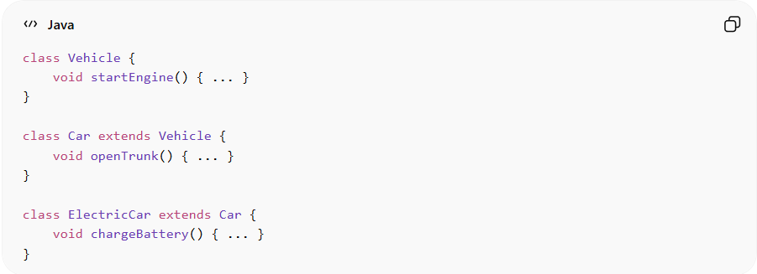
class Vehicle {
void startEngine() { ... }
}

class Car extends Vehicle {
void openTrunk() { ... }
}

class ElectricCar extends Car {
void chargeBattery() { ... }
}
Problems:
• Deep inheritance hierarchy → rigid and hard to extend
• Subclasses inherit all behavior, even if not needed
• Hard to reuse specific functionality in different contexts
• Tightly coupled classes → difficult to maintain

✅ Good Example
# Source: AI Source: Provided by: [Data Path: Persons Table -> ID Column: 1, Name_En Column: Motasem Essam] -> From: [ChatGPT] on [1/23/2026]
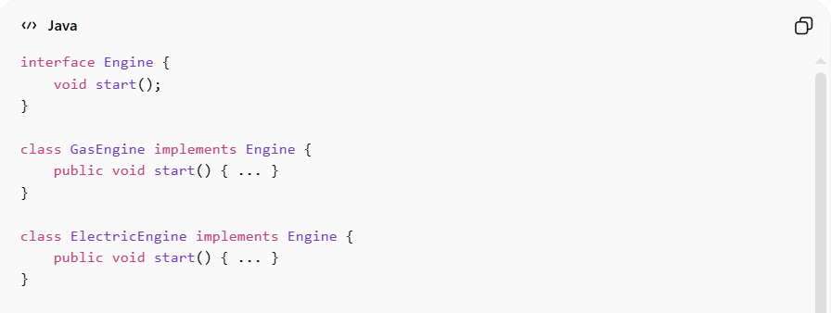
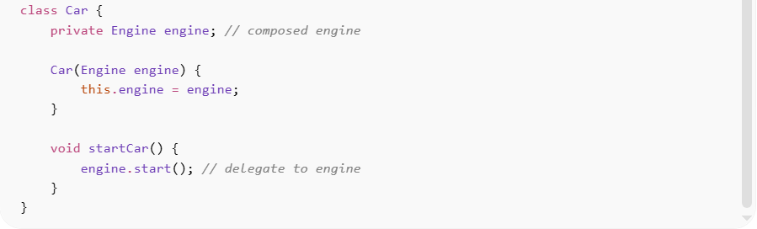
interface Engine {
void start();
}

class GasEngine implements Engine {
public void start() { ... }
}

class ElectricEngine implements Engine {
public void start() { ... }
}

class Car {
private Engine engine; // composed engine

Car(Engine engine) {
this.engine = engine;
}

void startCar() {
engine.start(); // delegate to engine
}
}
Benefits:
• Flexibility to swap engines without changing Car class
• Reduces coupling → easier to maintain and extend
• Supports modular design → reuse components in different contexts
• Avoids the pitfalls of deep inheritance hierarchies

⚡ When to Apply
# Source: AI Source: Provided by: [Data Path: Persons Table -> ID Column: 1, Name_En Column: Motasem Essam] -> From: [ChatGPT] on [1/23/2026]
• Always consider composition when designing new classes
• Especially useful for complex systems with varying behavior
• Works best with interfaces and dependency injection
• Combine with DRY, KISS, and high cohesion for clean, maintainable architecture

